Table of Contents

1 Use Case Diagram 2

2 Sequence Diagram 3

2.1 Log-in 3

2.2 Logout 3

2.3 Heatmap 4

2.4 Basic Location Report 5

2.5 Automatic Group Identification 6

3 Class Diagram 7

4 Logical Diagram 7

# 1 Use Case Diagram

|  |  |
| --- | --- |
| Login/Logout | Allows the admin and user to access and exit the web page |
| Basic Breakdown Report | Shows the breakdown of students in the SIS building by their year from 2013 to 2017, gender and school |
| Top-K Popular Places | Shows the most popular place, which is determined by the number of people in SIS at a specific time |
| Top-K Companion | See top-k other users who were co-located with a specified user (using MAC address) in a specified query window |
| Top-K Next Places | Shows the top-k next popular places that users located at place A are likely to visit in the next 15 minutes |
| Heatmap | Allow user to view crowd density at a specified floor in the SIS building, at a particular data and time |
| Automatic Identified Group List | Discover potential groups in SIS building at a given time/date based on users’ location traces |
| Bootstrap | Allows the admin to upload new data into the web page |
| Upload | Allows the admin to update data into the web page |

# 2 Sequence Diagram

## 2.1 Log-in



## 2.2 Logout



## 2.3 Heatmap

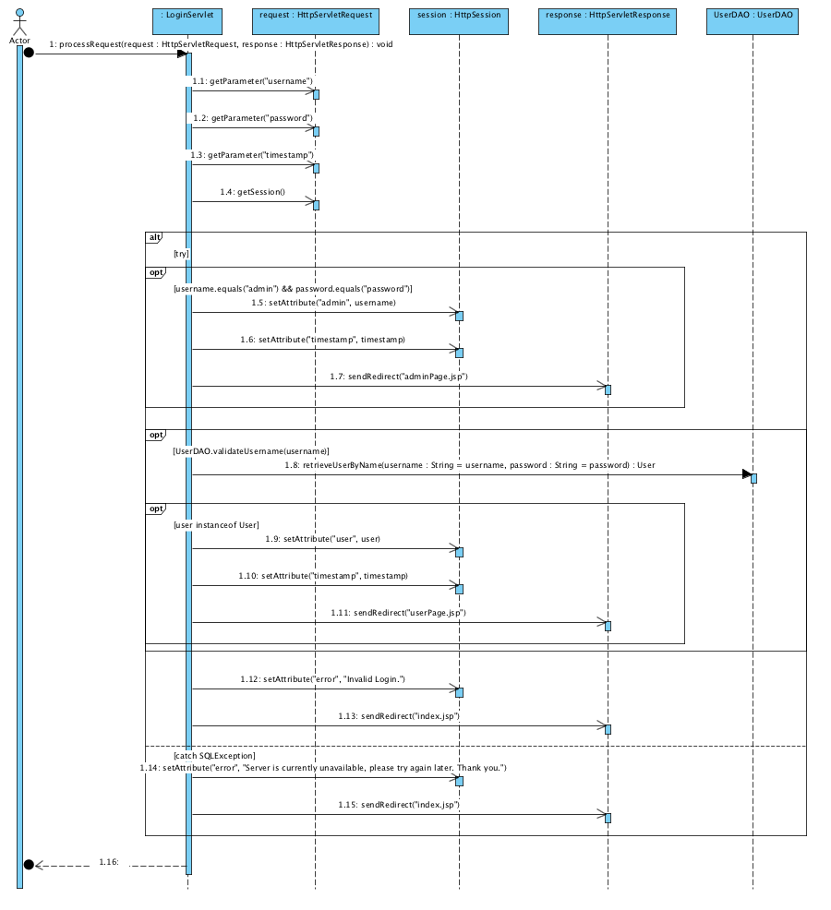

## 2.4 Basic Location Report



## 2.5 Automatic Group Identification

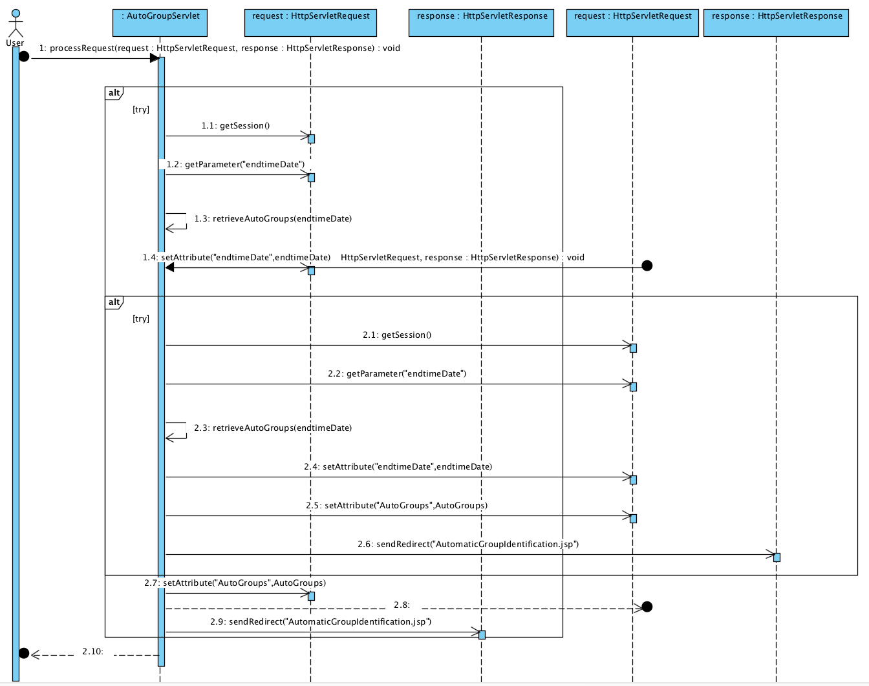

# 3 Class Diagram



# 4 Logical Diagram

